Topic 3
  - World Religion

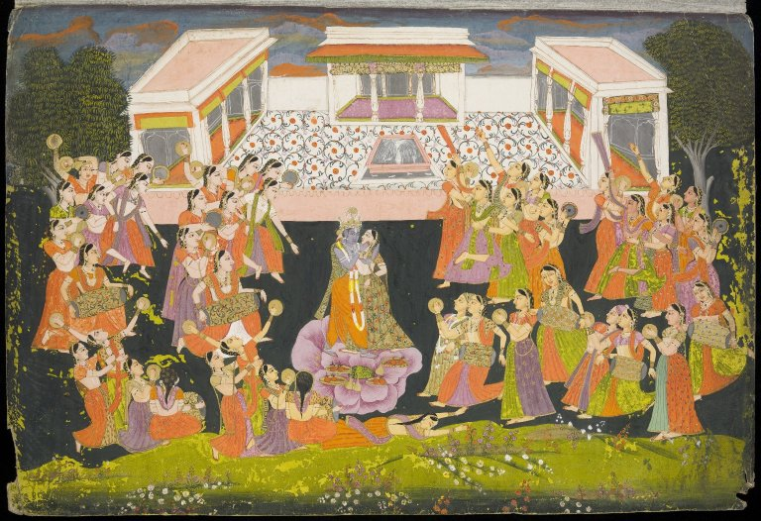
Tasawir, f.17v, © University of Edinburgh, CC BY, https://images.is.ed.ac.uk/luna/servlet/s/938lzk

Images
UoE Image Collections - http://images.is.ed.ac.uk/
Flickr CRC - https://www.flickr.com/photos/crcedinburgh
Flickr Interactive Content - https://www.flickr.com/people/interactive-content/
Flickr - https://www.flickr.com/
Pixabay - https://pixabay.com/
Europeana - https://www.europeana.eu/portal/en
Rijksmuseum - https://www.rijksmuseum.nl/

Media
Wikimedia Commons - https://commons.wikimedia.org/
Media Hopper Create - https://media.ed.ac.uk/
Open Media Bank - https://media.ed.ac.uk/channel/Open+Media+Bank
Open Media Snippets - https://media.ed.ac.uk/channel/Open+Media+Snippets
Vimeo - https://vimeo.com/
Youtube - https://www.youtube.com/
Free Music Archive - http://freemusicarchive.org/
Jamendo - https://www.jamendo.com/?language=en&p=tags

OER
Open.Ed - http://open.ed.ac.uk/
TES - https://www.tes.com/teaching-resources
Open Learn - http://www.open.edu/openlearn/
OER Commons - https://www.oercommons.org/
OER Africa – https://www.oerafrica.org/

Open Textbooks
OpenStax CNX - https://cnx.org/
Open Textbook Library - http://open.umn.edu/opentextbooks/

Models
Open.Ed on Sketchfab - https://sketchfab.com/openededinburgh/collections

Search Engines
Solvonauts - https://solvonauts.org/
Creative Commons Search - https://search.creativecommons.org/

